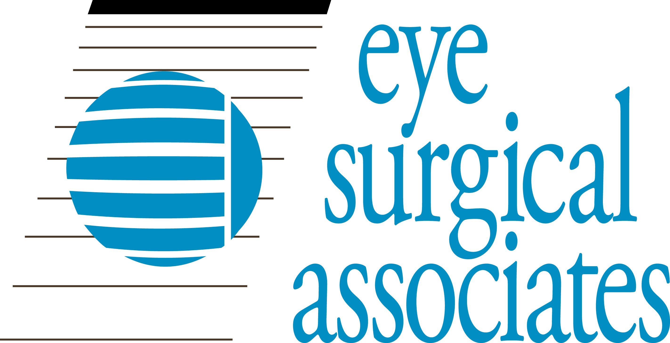
Gregory E. Sutton, M.D.
Vincent J. Sutton, M.D.
Thomas A. Graul, M.D.
Matthew H. Wood, M.D.
Donald P. Sauberan, M.D.
Daniel A. Chruscicki, M.D.
Jordan J. Rixen, M.D.
David W. Blodgett, M.D.
Thomas J.E. Clark, M.D.
Samuel L. Thomsen, M.D.
Kaylyn R. Jackman, O.D.

RELEASE OF MEDICAL INFORMATION
_________
Patient Name (Print) Medical Record Number Patient DOB
Patient identification confirmed. Staff signature: ________________________________________
I authorize the following provider:
Name: ___________________________________
Address:__________________________________
To release my health information as described
below to:
Eye Surgical Associates
1710 S. 70th St. Lincoln, NE 68506
P: 402-484-9000 F: 402-483-4223

I authorize Eye Surgical Associates to release my health information as described below.
To: ____________________________________
Address________________________________________________________________________

-OR- -OR-

Please release only the following information:
Please release my entire record
-OR-
Please release only the following information (check appropriate boxes and include other information where indicated):
Records from last _____years
Dr. Letter only-Date__________
OP Report Dates____________
Diagnostic Reports___________
Consultation reports (please supply doctors’ names): ____________________________________________
Other (please describe): ___________________________________________________________________
The identified information will be used for the following purpose:
My personal records
Sharing with other health care providers as needed
Other (please describe): _______________________________________________________________________
Please initial each item below to indicate your understanding.
I understand the information in my health record may include information relating to sexually transmitted disease, acquired immunodeficiency syndrome (AIDS), or human immunodeficiency virus (HIV). It may also include information about behavioral or mental health services, and treatment for alcohol and drug abuse.
I understand once the information below is released, it may be re-released by the recipient and the information may not be protected by federal privacy laws or regulations.
I understand I have a right to stop this authorization at any time. I understand if I stop this authorization, I must do so in writing to the practice. I understand the stopping this form will not apply to information that has already been released. I understand that stopping will not apply to my insurance company when the law provides my insurance company with the right to contest a claim under my policy.
I understand authorizing the use or release of this information is voluntary. I need not sign this form to ensure health care treatment.
________ / /_______
Patient Signature (or Signature of Person Completing Form if Not Patient*) Date
*Relationship to patient: Parent Legal Guardian Other:
(This Authorization expires one year from date signed.)
Eye Surgical Associates 1710 So. 70th St. Lincoln , NE 68506-1601 Phone# 800-742-2224 402-484-9000 Fax# 402-483-4223 (5/2021)

